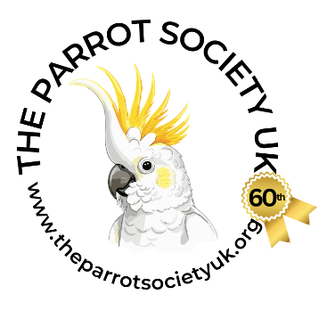
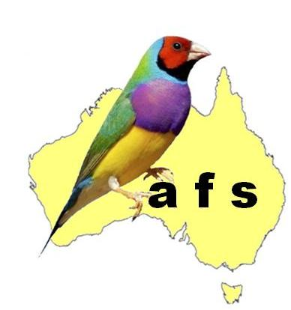
The Parrot Society UK

Participant Application Form & Declaration

All participants bringing birds for sale must be members of The Parrot Society UK OR THE Australian Finch Society

Event Details
Event: The Summer Show
Date: 5th July 2026
Venue: Stafford County Showground, Staffordshire, ST18 8BD

Section 1: Participant Details
Full Name: ………………………………………………………………………………………………………………………
Address: ………………………………………………………………………………………………………………………….
Telephone / Mobile: ………………………………………………………………………………………………………...
Email: ……………………………………………………………………………………………………………………………...

Section 2: Membership Details (Mandatory)
Bringing birds for sale: Yes / No (please circle correct answer)
If Yes PSUK Membership Number: ………………………………

Section 3: Bird Details
Parrot-type (incl. Budgies) Number: ………………………………
Canaries Number: ………………………………
Finches Number: ………………………………
Additional species Number: ……………………. (Provide details on additional piece of paper and attach)
Total number of birds: ………………………………

Section 4: Premises of Origin
Address where birds are normally kept: …………………………………………………………………………….
County Parish Holding (CPH) Number: ……………………………… (Required for captive birds)
Have the birds been registered on the Captive Bird Register: Yes / No (please circle correct answer)

Section 5: Declaration (Mandatory – Must be signed)
I confirm and declare that:
- I have read and will comply with all biosecurity requirements.
- To the best of my knowledge, the birds have not been exposed to notifiable avian disease and show no signs of infection or disease.
- The birds do not originate from premises under any notifiable avian disease restrictions or control zones.
- I will present birds for visual health inspection and understand suspect birds may be isolated, with movements potentially restricted until APHA instructions are received.
- I meet all membership requirements and will provide proof if requested. I am a current member of The Parrot Society UK for any birds brought for sale, and/or a member of the appropriate Cage Bird Society for birds entered for showing.
- I will not remove birds from the premises without the organiser’s permission. I understand that birds may need to remain on-site if notifiable avian disease is suspected or if the venue falls within a disease control zone.
- I will provide accurate records and monitor birds for signs of disease.
- I understand that failure to comply may result in refusal of entry or removal from the event.

Signed: ………………………………………………….. Date: …………………………………………………..

Name (BLOCK CAPITALS): ……………………………………………………….………………………………

Data Protection Notice
The organiser will retain this form, including contact and membership details, for a minimum of three months for traceability and disease control purposes, in accordance with legal requirements.

The Parrot Society UK, Audley House, Northbridge Road, Berkhamsted, Herts, HP4 1EH
Telephone: +44 (0)1442 872245 www.theparrotsocietyuk.org
Chairman: D. Dickason • Secretary: L. Rance

